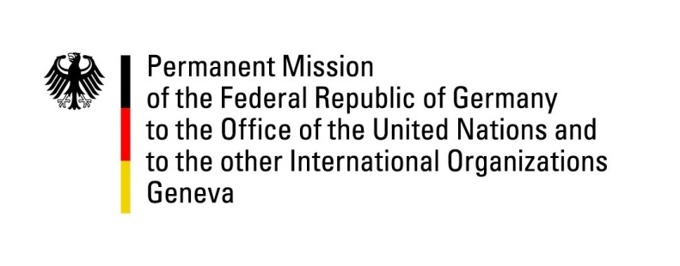

United Nations Human Rights Council
26th Session of the UPR Working Group

Geneva, 1 November 2016
---
German recommendations
to
Iceland

Mr. President,

Germany welcomes the delegation of Iceland to the UPR and commends the government for its commitment to upholding human rights and its commitment to advocate human rights and fundamental freedoms in its bilateral and multilateral relations.
The government has however not yet ratified the 1961 Convention on the Reduction of Statelessness (CRS), as indicated during its first review.

Germany would like to submit the following recommendations:

- Ratify as soon as possible the optional protocols to the Convention against Torture and other Cruel, Inhuman or Degrading Treatment or Punishment (OPCAT) and the third optional protocol to the Convention on the Rights of the Child (CRC);
- Ratify the UN Convention for the Protection of All Persons from Enforced Disappearance, and recognize the competence of the Committee on Enforced Disappearances to receive and consider communications from or on behalf of victims and other states parties.

Thank you, Mr. President.

Question submitted in advance by Germany:

- Has the government of Iceland taken up concrete measures to ratify CRS? If so, could you outline these steps.

- What steps has the government of Iceland taken to establish a national human rights institution, fully compliant with the Paris Principles and in consultation with civil society, and drawing on the expertise, experience and network of the Icelandic Human Rights Centre (ICEHR) in this process.

